Exercise Problems for Module 10
The exercise problems in Module 10 provide practice with schema conversion using the conversion rules presented in module 10.
- Convert the ERD shown in Figure 1 into tables. List the conversion rules used and the resulting tables with primary keys, foreign keys, other columns, and not null constraints for foreign keys. You do not need to provide CREATE TABLE statements.
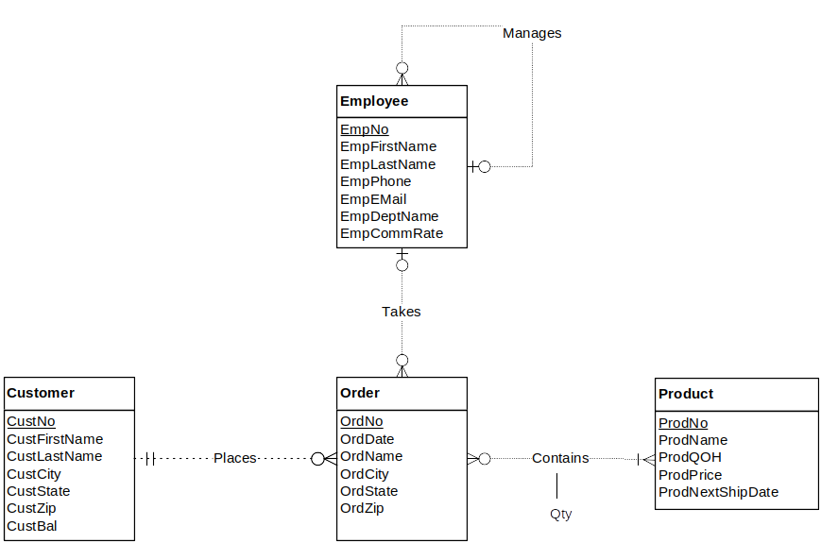
Figure 1: ERD for Problem 1
- Convert the ERD shown in Figure 2 into tables. This ERD is identical to problem 1 except for the use of an associative entity type instead of the M-N relationship. You only need to indicate the conversion rules and table design for the associative entity type.
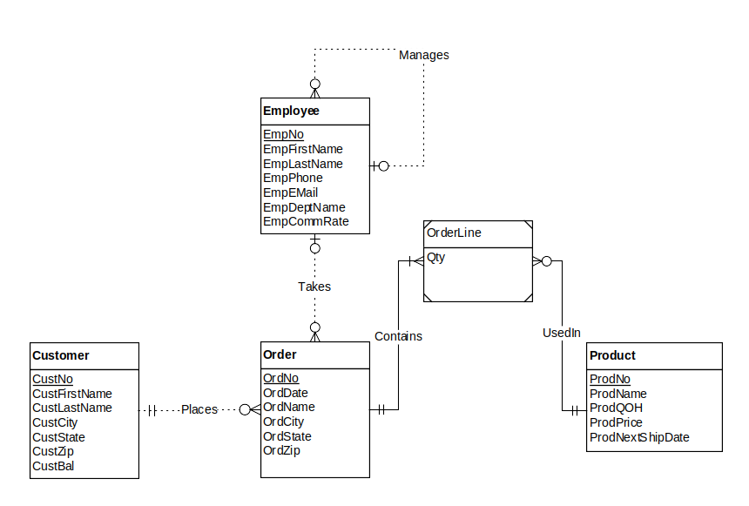Figure 2: ERD for Problem 2

